ENCP 100 WS2020

Assignment 03

ZEESHAN HOODA

X61L — 01/30/20 and 2:00 P.M.

**ANSWERS FOR QUESTION 1:**

|  |  |
| --- | --- |
| Question | Value |
| a | a =  -3 -7 5  3 -13 4 |
| b | b =  3.0000  13.0000  7.2832 |
| c | c =  7.8496 20.4911 10.4248 |
| d | d =  19.1416 |
| e | e =  8.5000 |
| f | f =  8.6603 |
| g | g =  18.9911 -16.7080 22.0000 |
| h | h =  19.1416 |
| i | i =  0.2157 -0.1961 -0.0784  -0.4706 -0.1176 0.3529  0.6667 0.6667 -0.3333 |
| j | j =  -25.5000 |
| k | k =  1.0000 -0.0000 0.0000  0 1.0000 0.0000  -0.0000 0 1.0000 |
| l | l =  2 3 |

**MATLAB CODE FOR QUESTION 1:**

clear all; clc; close all;

A = [5; 7; 1];

B = [-1, 3, pi];

C = [ -1, 3, 9; 6, -4, 2];

D = [ 2, 10, 4; 3, 9, -2];

E = [5, 3, 2; -2, 0.5, 1; 6, 7, 3];

a = C - D

b = 2*B' + A

c = B*E

d = B*A

e = trace(E)

f = norm(A)

g = cross(A', B)

h = dot(A', B)

i = E^-1

j = det(E)

k = E*E^-1

l = size(D)

**ANSWERS FOR QUESTION 2:**

|  |  |
| --- | --- |
| Question | Value |
| Total cost of all parts together | total_cost =  323.3958 |
| Average material cost | avg_material_cost =  0.2007 |
| Material cost of part with largest labour cost | max_labour_material_cost =  94.9500 |
| Number of parts printed in 3 hrs or more | numParts =  3 |

**MATLAB CODE FOR QUESTION 2:**

clear all; clc; close all;

table = [ 50.05, 2, 0, 0, 0, 0, 0;...

0.10, 53, 12.50, 0, 0, 0, 0;...

2.50, 5, 23.99, 0, 0, 0, 0;...

0, 0, 0, 0.02, 5.43, 7.50, 3;...

0, 0, 0, 0.23, 2.21, 7.50, 5;...

0, 0, 0, 0.42, 0.33, 10.55, 9;...

0, 0, 0, 0.11, 0.43, 5.00, 1; ];

material_cost = table(:, 5).*table(:, 4);

labour_cost = table(:, 6).*table(:, 7);

printed_cost = material_cost + labour_cost;

purchased_cost = 1.07*table(:, 1).*table(:, 2) + table(:, 3);

total_cost = sum(printed_cost) + sum(purchased_cost)

avg_material_cost = mean(nonzeros(table(:, 5).*table(:, 4)))

[max_labour_cost , i] = max(labour_cost);

max_labour_material_cost = table(i, 6)*table(i, 7)

numParts = sum(table(:, 7)>=3)

**ANSWERS FOR QUESTION 3:**

Figure 1:

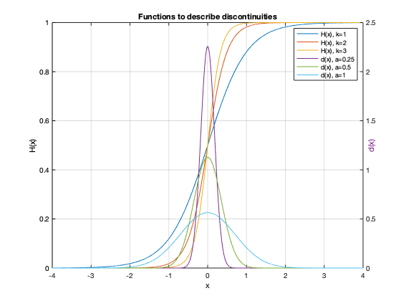

**MATLAB CODE FOR QUESTION 3:**

clear all; clc; close all;

x = -4:0.001:4;

k = [ 1, 2, 3 ];

a = [ 0.25, 0.5, 1 ];

Hx = 1./(1 + exp(-2*k(1)*x));

Hx1 = 1./(1 + exp(-2*k(2)*x));

Hx2 = 1./(1 + exp(-2*k(3)*x));

deltax = (1./(abs(a(1))*sqrt(pi))) * exp(-(x/a(1)).^2);

deltax1 = (1./(abs(a(2))*sqrt(pi))) * exp(-(x/a(2)).^2);

deltax2 = (1./(abs(a(3))*sqrt(pi))) * exp(-(x/a(3)).^2);

figure;

plotyy(x, [Hx; Hx1; Hx2], x, [deltax; deltax1; deltax2]);

% plot(x, [Hx; Hx1; Hx2; deltax; deltax1; deltax2]);

grid;

legend("H(x), k=1", "H(x), k=2", "H(x), k=3", "d(x), a=0.25", "d(x), a=0.5", "d(x), a=1");

xlabel("x");

yyaxis left

ylabel("H(x)");

yyaxis right

ylabel("d(x)");

set(gca, 'YTick', []);

title("Functions to describe discontinuities");

**ANSWERS FOR QUESTION 4:**

Image: scatter.png

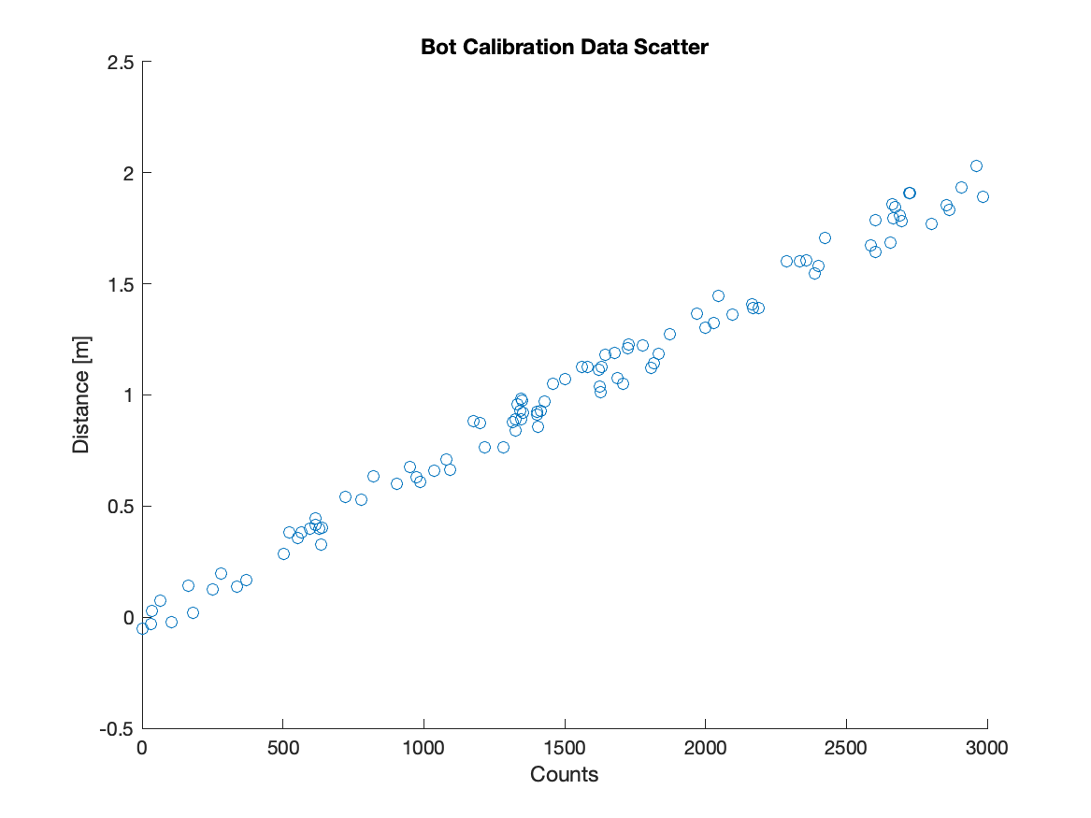

Image: bestFit.png

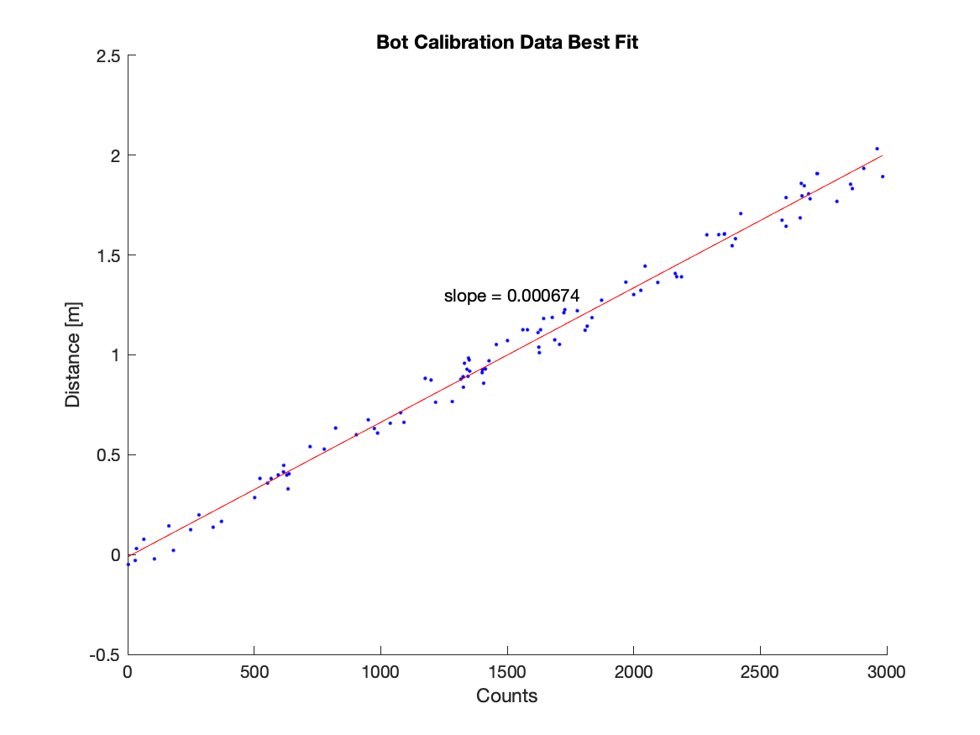

**MATLAB CODE FOR QUESTION 4:**

clear all; clc; close all;

% NOTE: .dat files were stored in a seperate directory

% to keep my git repo organized.

data = csvread('data/botData.dat');

counts = data(:,1);

dist = data(:, 2);

figure;

scatter(counts, dist);

title("Bot Calibration Data Scatter");

xlabel("Counts");

ylabel("Distance [m]");

% NOTE: Images also stored in a seperate directory

% because organization is key.

print -dpng img/scatter.png

figure;

scatter(counts, dist, '.b')

% Calculating and plotting the line of best fit

p = polyfit(counts, dist, 1);

f = polyval(p, counts);

hold on

plot(counts, f, '-r');

% Converting slope value to string and placing on plot

slope_text = sprintf("slope = %f", p(1));

text(1250, 1.3, slope_text);

title("Bot Calibration Data Best Fit");

xlabel("Counts");

ylabel("Distance [m]");

print -dpng img/bestFit.png

**ANSWERS FOR QUESTION 5:**

Total number of oil spills: 7319

Average oil spill size [m^3]: 12.46281

Total volume of oil spilled [m^3]: 91215.30

Range of spill sizes: 0 - 6500

Year with maximum oil spill: 1980

Number of spills larger than 1000 m^3: 12

Image: hist.jpeg

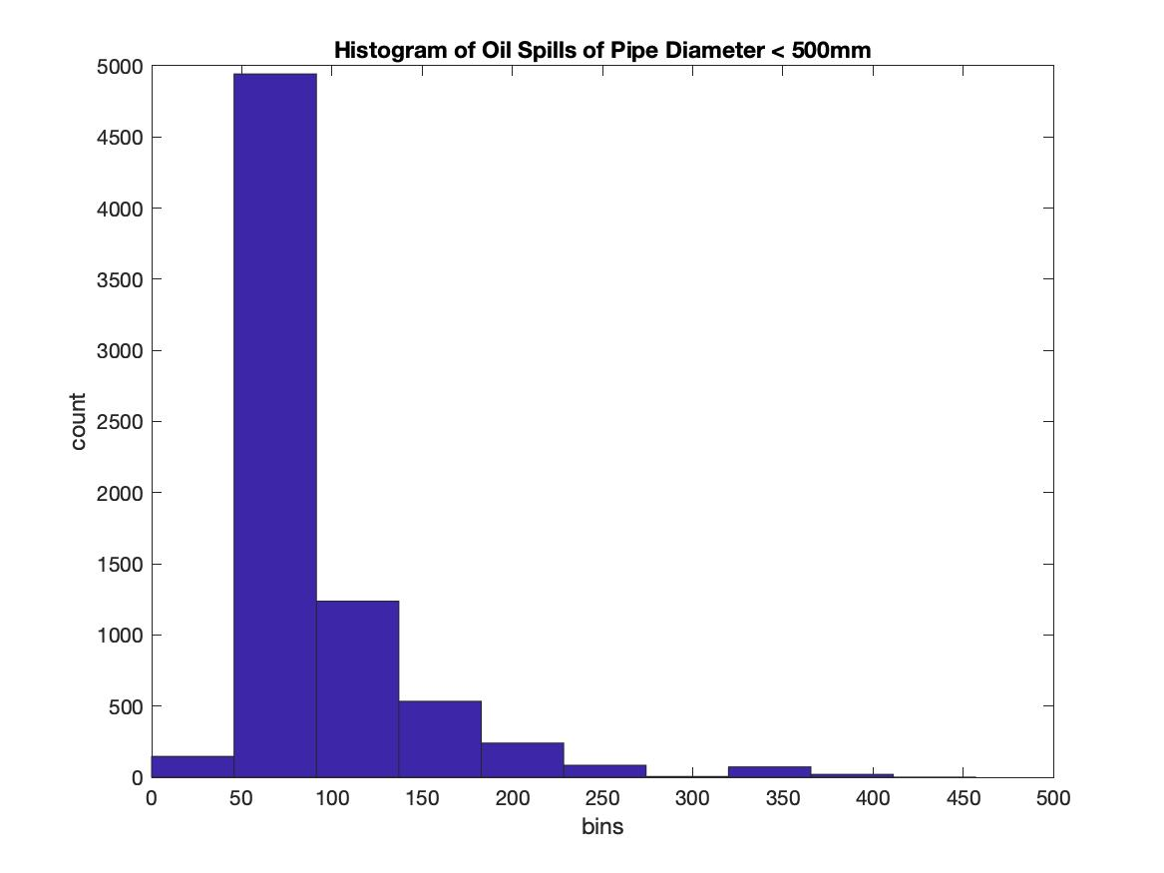

**ANSWERS FOR QUESTION 5 (cont’d):**

Image: image02.jpeg

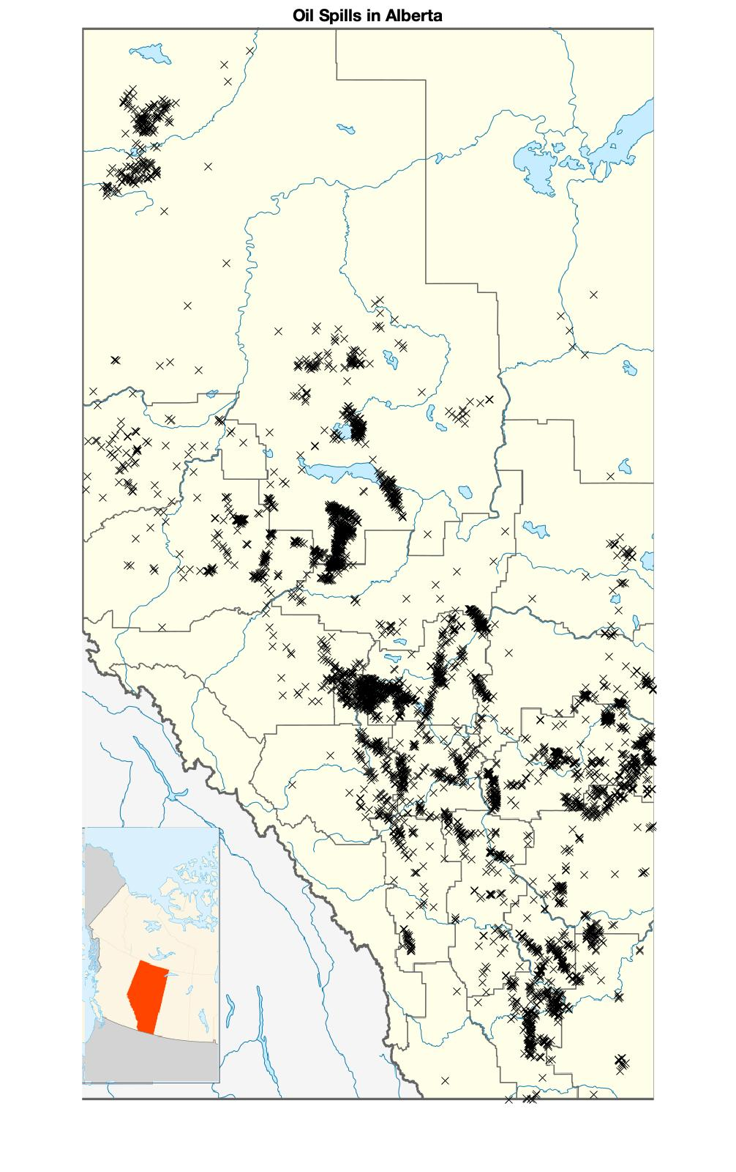

**MATLAB CODE FOR QUESTION 5:**

clear all; clc; close all;

data = csvread("data/oilSpillData.dat");

% Determine # of oil spills

num_of_spills = length(data(:,1));

fprintf("Total number of oil spills: %d\n", num_of_spills);

% Determine average spill size

avg_spill_size = mean(data(:, 5));

fprintf("Average oil spill size [m^3]: %.5f\n", avg_spill_size);

% Determine total volume of oil spilled

total_spill_vol = sum(data(:, 5));

fprintf("Total volume of oil spilled [m^3]: %.2f\n", total_spill_vol);

% Determine range of spill sizes

spill_range = [min(data(:, 5)), max(data(:, 5))];

spill_range2 = range(data(:, 5));

fprintf("Range of spill sizes: %d - %d\n", spill_range(1), spill_range(2));

% Determine year of max oil spill

[m, i] = max(data(:, 5));

max_year = data(i, 1);

fprintf("Year with maximum oil spill: %d\n", max_year);

% Determine number of oil spills larger than 1000m^3

large_spills = sum(data(:, 5) > 1000);

fprintf("Number of spills larger than 1000 m^3: %d\n", large_spills);

% Create histogram of spills with pipe diameters less than 500mm

hist_data = [];

for i = 1:length(data(:, 4))

if data(i, 4) < 500

hist_data = [hist_data data(i, 4)];

end

end

figure;

hist(hist_data);

title("Histogram of Oil Spills of Pipe Diameter < 500mm");

xlabel("bins");

ylabel("count");

print -djpeg img/hist.jpeg

% Create scatter plot of longitude vs lattitude

lon = data(:, 6);

lat = data(:, 7);

figure;

ab_map = imread("data/albertaMap.png");

imshow(ab_map);

title("Oil Spills in Alberta");

longNew = 75*(lon + 120);

latNew = (1406/11)*(60 - lat);

hold on

scatter(longNew, latNew, 'xk');

print -djpeg img/image02.jpeg